Algorithms CS435

October 2021

Below is the template version of breadth-first search. The hook operations are in bold font.

**Algorithm *BFS(G)***

**Input** graph ***G***

**Output** labels the edges of *G*as discovery edges **and cross edges**

***initHesult(G)***

**for all u E** *G. vertices()*

*serLabel(u, UNEXPLORED)*

**postinitVertex(u)**

**for all** *e c aedges()*

*setLabel(e, UNEXPLORED)*

***postlnitEdge(e)***

***for al l v*** c *G.vertices()*

*if* ***isNextComponent(G, v)***   
 ***preComponentVisit(G, v)***

*bfsTraversal(G, v)*

***postCornponentVisit(G, v) return result(G)***

**Algorithm *bfsTraversal(G,*** *s)*   
 ***Q***  *new empty queue*

*setLabel(s, VISITED)*

*Q. enqueue(s)*

***startBFS(G, s)***

**while** *—.QisEinpiy() do*

*v*  *Q.dequeue()*

***preVertexVisit(G, v)***

**for** *all e* **E** *GincidentEdges(v)* **do**   
 ***preEdgeVisit(G, v,***

***if getLabel(e) - UNEXPLORED***   
 ***w***  ***opposite(v, e)***

***edgeVisit(G, v, e, w)***

**Algorithm *isNextComponent(G, v)***   
 **return** *getLabel(v) =* ***UNEXPLORED***

**if** *getLabelM*  *=* ***UNEXPLORED***

***preDiscoveryEdgeVisit(G, v, e, w)*** *setLabel(e, DISCOVERY)*

*seiLabei(w, VISITED)*

*Q. enqueue(w)*

else

***postDiscoveryEdgeVisit(G, v, e, w)***

*setLabel(e, CROSS)*

***crossEdge Visit(G, v, e, w)***

***postEdgeVisit(G, v, e)***   
 ***postVertexVisit(G, v)***   
***finishBFS(G, s)***

**Algorithms CS435**

***List ADT:***

***first(), last(), before(p), after(p), replaceElement(p, o), swapElements(p, q),***

insertBefore(p, o), insertAfter(p, o), insertFirst(o), insertLast(o), remove(p),

size(), isEmpty(), elements() (All of the operations using Rank, but inefficient)

Sequence ADT:

(All of the above List operations), elemAtRank(r), replaceAtRank (r, o),

insertAtRank(r, o), removeAtRank(r), atRank(r), rankOf(p)

BinaryTree ADT:

root(), parent(v), children(v), leftChild(v), rightChild(v), sibling(v),

isInternal(v), isExternal(v), isRoot(v), size(), elements(), positions(),

swapElements(v, w), replaceElement(v, e)

Dictionary ADT (HT and BST based)

findValue(k), insertItem(k, e), removeItem(k), keys(), values(), items()

(General) Graph ADT

numVertices(), numEdges(), vertices(), edges(), aVertex(),

degree(v), adjacentVertices(v), incidentEdges(v), endVertices(e),

opposite(v, e), areAdjacent(v, w), valueAt(v), valueAt(e)

insertVertex(o), removeVertex(v), insertEdge(v, w, o), removeEdge(e)

***Algorithm Design***

***1.***  ***[25] Given*** a graph G=(V,E) and **a *Sequence* T** of vertices where T⊆V, design **a pseudo code**

algorithm ***findEdges(G,*** T) that finds the edges that connect any pair of the vertices ***in*** Sequence

T. For example, if T=(C,D,F) and G is the graph above, then **findEdges** would return a

sequence {(F,C),(C,D),(D,F)}. Similarly, if **T={B,D,F},** then **findEdges** would return asequence *{(D,F)}* since (D,F) is the only edge connecting any pair of the vertices in T. To receive full   
credit, you must use the BFS *Template* with no unnecessary loops other than those *in* the  
Template *[5-10* points]. **Hint:** note thatT is a **Sequence,** NOTa graph. Use any data structures*if they* improve the efficiency of your solution which could affect how you use the template.

***[10]*** Analyze the complexity of your algorithm by analyzing your pseudo code and **each line of the *above* BFS template. Do line by line analysis on the template algorithm on page 1.**

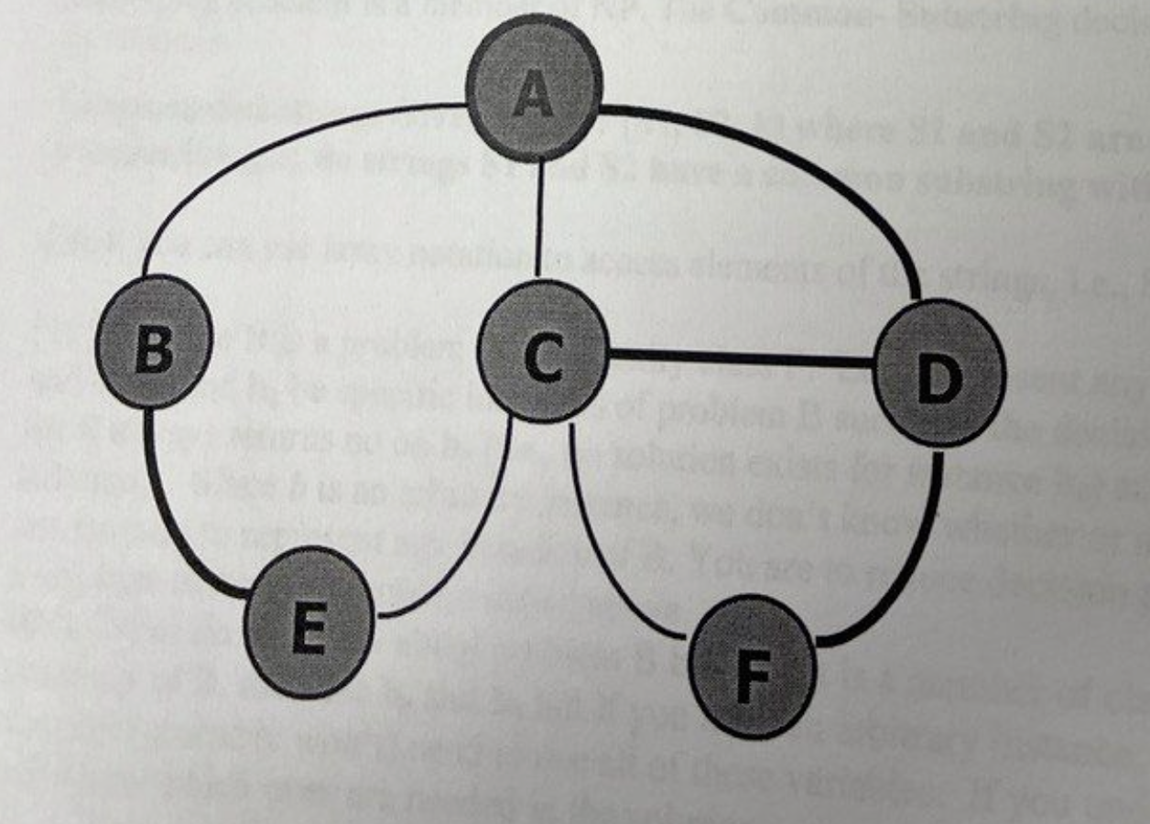

|  |  |
| --- | --- |
| **Algorithm findEdges(G, T)**  **vertexOfT := new Dictionary(HT)**  **for all v in T.elements() do**  **vertexOfT.insertItem(v, YES)**  **return BFS(G)**  **Alothitm initResult(G)**  **result := new Stack**  **Algorithm postDiscoveryEdgeVisit(G, v, e, w)**  **if vertexOfT .findValue(v)=YES /\ vertexOfT .findValue(w)=YES then**  **result.insertLast((v,w))**  **Algorithm result(G)**  **return result** |  |

2. [10] Given a graph G=(V,E) and a Sequence **T** of vertices where T⊆V, design a pseudo code algorithm **isClique(G, T)** that decides whether or not the vertices in **T** form a clique. A clique **T** is asubset of the verticesof **G** such that every vertex in **T** is adjacent to every other vertex in **T**.   
 If the vertices in T form a clique, then return true, otherwise return false. For example, the sequence **T**={C,D,F] is a clique in the above graph because each vertex is adjacent to the other two vertices in Sequence **T**. Similarly, every pair of adjacent vertices like S={B,D} is a clique of size 2. However, if **T**={A,C,F,D}, then **isClique** would return false since **A** and **F** are not adjacent. **Hint**: this can be decided based on the number of edges returned by your solution to   
question 1above together with the number of vertices in **T.**

|  |  |
| --- | --- |
| **Algorithm isCilque(G, T)**  **vertexOfT := new Dictionary(HT)**  **S := T**  **for all v in T.elements() do**  **vertexOfT.insertItem(v, YES)**  **return BFS(G)**  **Alothitm initResult(G)**  **isClique := True**  **Algorithm postDiscoveryEdgeVisit(G, v, e, w)**  **if vertexOfT .findValue(w)=YES /\ isClique is true then**  **cnt = 0**  **for all e in G.incidentEdges(w) do**  **o := G.oppsite(w, e)**  **if vertexOfT .findValue(o)=YES then**  **cnt ++**  **if cnt != S.size() – 1 then**  **isClique = false**  **Algorithm result(G)**  **return isClique** |  |

3. [35] Design a pseudo-code algorithm, **totalWeightPerComponent(G,T),** that takes a weighted graph **G=(V,E)** and a Sequence **T** of edges from G, i.e., T⊆E and returns a Sequence containing the total edge weight of each **connected component** of the subgraph formed by **GT=(V,T),** i.e., the subgraph composed of all the vertices in G but only the edges in T. Your output should be a Sequence containing the total edge weight in each component, i.e., the sum of the weight of the edges ineach component (this will of course include only the edges in T and there will likely be more components than in the graph **G** since **T** may not include all the edges in **E**). For example, suppose a graph has two components (after excluding the edges not in T); if the first component has 8 vertices and 20 edges with total edge-weight of 55 (the sum of the weights of the 20 edges) and if the second has 9 vertices and 28 edges with total edge-weight of 47, then your algorithm would return a Sequence containing {55,47}. [5-10] bonus points if there are no unnecessary loops other than those in the Template. **Hint:** use labels like we did in the homework and examples in the notes to skip vertices and/or edges

|  |  |
| --- | --- |
| **Algorithm totalWeightPerComponent(G, T)**  **edgeOfT := new Dictionary(HT)**  **for all v in T.elements() do**  **edgeOfT.insertItem(e, YES)**  **return BFS(G)**  **Alothitm initResult(G)**  **perWeightList := new Dictionary(HT)**  **cmp = 1**  **perWeightList.insert(cmp, 0)**  **Algorithm preComponentVisit(G, v)**  **cmp += 1**  **Algorithm postDiscoveryEdgeVisit(G, v, e, w)**  **if edgeOfT.findValue(e)=YES then**  **t := perWeightList.findValue(cmp) + e.getWeight()**  **perWeightList.insertItem(cmp, t)**  **Algorithm result(G)**  **return perWeightList** |  |

**NP and NP-Complete**

**Decision Problems and Reductions**

**4.**  **(a) [10]** A substring of a string S is a consecutive sequence of characters that occurs in S. For example, the substrings of a string "abcc" are the empty string "", and "a", "b", "c", **"ab", "bc",** "cc", "abc", "bcc", and *"abcc".* Given two strings, a common substring would be a substring thatoccurs in both strings. For example, given S1 ="abedefg" and S2= "xyzcdefabc”, then "def”, *"cde", and* "abc" are common substrings of S1 and S2 with length 3. Prove that the **Common-Substring** problem is a member of NP. The **Common- Substring** decision problem can be stated as follows:

**Common-Substring: Given a triple (S1, S2, k) where S1 and S2 are strings and k is a positive integer, do strings S1 and S2 have a common substring with length k?**

***Hint:*** you can use array notation to access elements of the strings, i.e., **S1[i].**

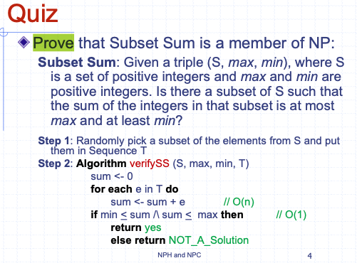

|  |  |
| --- | --- |
| Algorithm commonSubString(S1, S2, k)  dictS1 := new Dictionary(HT)  dictS2 := new Dictionary(HT)  dictS1 := makeDict(S1, k)  dictS2 := makeDict(S2, k)  result := new Stack  iter = dictS1.items()  while iter .hashNext() then  (key, value) := iter.next()  if dictS2.findValue(key) then  result.insertLast(value)  return result  Algorithm makeDict(S, k)  i := 0  dictS := new Dictionary(HT)  while i < i.size()-k do  dictS.insertItem(minS[i:i+k], 1)  i := i + 1  return dictS |  |
| Randomly pick string of elements with length k from S1 or S2 and them in Sequence T  Algorithm verifyCSS(S1, S2, k, T)  for each e in T.elements() do  if checkContains(S1, e) /\ checkContains(S2, e) then  return YES  return NO_A_Solution | O(n^2)This line is poly time |

**The Common-Substring problem is a member of NP because it can be verified in polynomial time.**

**5.** [10] Suppose B is a problem in complexity class P. Let ***b*** represent any arbitrary instance of B

and let **bo** and **b1** be specific instances of problem B such that the decision/verification algorithm   
for B always returns no on **bo** (i.e., no solution exists for instance **bo**) and yes on **b1** (has a solution). Since *b* is an arbitrary instance, we don't know whether or not ***b***has a solution so it can be used to represent any instance of B. You are to reduce decision problem B to the **Common-Substring** problem stated above.

**Hint:** What do weknow about problem B because it is a member of class P? If you need specific instances of B, then use **bo** and **b1** but if you need an arbitrary instance, then use ***b;***note that you may not (probably won't) need to use all of these variables. If you understand reductions, you will know which ones are needed in the solution.

**Problem B can be reduced to the Common-Substring problem, utilizing the fact that B is in the complexity class P.**

**To reduce problem B in complexity class P to the Common-Substring problem, we can use an arbitrary instance b of problem B and construct two strings s1 and s2 such that s1 and s2 have a common substring of length 1 if and only if b has a solution.**

|  |  |
| --- | --- |
| ReduceBtoCommonSubstring(b):  S1 = EncodeInstance(b) // Convert instance b of problem B into a string S1  S2 = "abc" // Arbitrary string used for the reduction  k = 3 // Length of the common substring to search for  result = CommonSubstring(S1, S2, k)// Invoke the Common-Substring function  R := new Stack  R.insertLast(2)  if result == True then  return (R, 2, 2)  else  return (R, 1, 1)  ReduceBtoCommonSubstring(S,b):  If B(S,b)=YES  Return b1  Else return b0 |  |

**Algorithms CS435**

6. [10] Given a graph G, the **Graph Coloring problem** attempts to assign colors to each vertex of G such that no two adjacent vertices are the same color; the optimization problem tries to do this with the fewest number of colors. Convert/restate the **Graph Coloring problem** (finding the minimum number of colors needed) as a decision problem that can decide whether the instance has a solution.

**Assuming there is no cycles in graph the minimum no of colors will be 2**

**If each edge on graph has n(n-1)/2 then we need n colors**

|  |  |
| --- | --- |
| Algorithm **graphColoring**(G)  return BFS(G)  Algorithm **initResult**(G)  colorDict = new Stack  colorDict.insert(Blue)  colorDict.insert(Red)  colorCNT := 0  Algorithm **preComponentVisit**(G, v)  cntComp ++  Algorithm visitCrossEdge()  colorDict.insert(RandomNewColor)  Algorithm **result**(G)  return colorDict.size()  Algorithm getIndex()  colorCNT ++  Return colorCNT % colorDict.size()  Algorithm **preDiscEdgeVisit**(G, v, e,w)  w.color = colorDict[getIndex()] | Algorithm **graphColoring**(G)  return BFS(G)  Algorithm **initResult**(G)  colorDict = new Stack  colorDict.insert(Blue)  colorDict.insert(Red)  colorCNT := 0  Algorithm **preComponentVisit**(G, v)  cntComp ++  Algorithm visitCrossEdge()  colorDict.insert(RandomNewColor)  Algorithm **result**(G)  return colorDict.size()  Algorithm getIndex()  colorCNT ++  Return colorCNT % colorDict.size()  Algorithm **preDiscEdgeVisit**(G, v, e,w)  w.color = colorDict[getIndex()] |

7. An independent set is a **subset** T of the vertices of G=(V,E), i.e., T⊆V such that none of the vertices in T are adjacent to each other. For example, in the graph above, the vertices A, E, and F form an independent set of size 3 since none of these vertices are adjacent. Similarly, vertices B and D form an independent set of size 2 since B and D are not adjacent.

The **Independent Set** decision problem can be stated as follows:

**Independent-Set: Given an integer K and a graph G, does G have an independent set of size K?**

[10]: Prove that the **Independent Set problem** is a member of **NP.**

|  |  |
| --- | --- |
| Algorithm verifyIndepSet(G, T, K)  vertexOfT = new Dictionary(HT)  for each v in T.elements() do  vertexOfT.insertItem(v, YES)  Algorithm initResult(G)  isSubset := True  Algorithm postDiscVertexVisit(G, v, e, w)  if vertexOfT.fildValue(v) = YES /\ vertexOfT.fildValue(w) = YES then  isSubset := False  Algorithm result(G)  return isSubset | **It is poly time O(nlogn)** |

**Answer**

**The Independent Set problem is a member of NP because given a potential solution, it can be verified in polynomial time, and if a solution exists, it can be found in polynomial time using a nondeterministic algorithm.**

**8.** [5] The **Clique** optimization problem searches for the largest clique in a graph **G. The Clique** decision problem can bestated as follows:

**Clique: Given a pair (G, K) where G=(V,E) is a graph and *K* is a positive integer, does there exist a clique S in G, such that size of S equals K?**

Can we conclude anything if there is a polynomial time reduction of the **Clique** problem to the **Independent Set** problem (assume that you correctly answered the previous question regarding the **Independent Set** problem)? Recall, from the chart of reductions in the lecture notes, that Circuit-Sat has been reduced to SAT and SAT has been reduced to 3-CNF-Sat and 3-CNF-Sat has been reduced to the **Clique** problem. If there is a conclusion, then state and justifyit otherwise explain why nothing can be concluded.

**Notation: A —>p** B means instances of problem **A** can be reduced to instances of problem B by function p in polynomial time.

9. Answer **true** or **false** to each of the following questions (a) to (j). if true, briefly justify your answer (using at most 2-3 sentences in the space provided below). If false, give a counter example, such as, "A could be MST and B could be halting problem" or "A could be in NPC and B in P", etc. **Zero points without a justification**. If true, explain based on the definitions of P, NP, NPH, and NPC.

For parts (a) to (j), assume A and B are **specific** decision problems and that the subscript *f* denotes the polynomial-time function for reducing A to B. **(Please put your explanation on the same *page* or the back so it's easy to find; this will save me a lot of time and will result in the grading being_ finished sooner)**

**(a) [2] *if* A —>fB and A∈P, then B∈P**

False, because A can be NP and B can be P, then you cannot NP reduce to P

**(b) [2] if A —>f B and B -> gA, then A, B∈P**

False, because A can be NP and B can be P, then you cannot NP reduce to P

**(c)[2] if A ->fB and A∈NPC, then B∈NPC**

True, because A and B always has solutions, and they are same

**(d) [2] if A ->f B and B∈NPC, then A∈NP**

False , Because A can have solution in P , while B can be NPH

**(e) [2] if A ->f B and B∈P, then A∈NP**

False, If B is p and A is NP or A can be NPH then it’s false , as we can find solution for A and verify it but we cannot verify solution for B.

**(f) [2] if A->f B and A, B∈NP, then B->gA**

False, because A can be MST of P, but B can Subset Problem of NP

**(g) [2] if A->f B and A∈NPH and B∈P, then P =NP**

False, because A cannot be reduced to P

NPH cannot be reduced to P

**(h) [2] if A->f B and B∈NP, then A∈NP**

False, A can be NP and B can be P

**[2] if A->f B and B∈NPH, then A∈NP**

False because B cannot be P, whereas A can be P

**(j) [2] if A->f B and A is the Halting Problem, then B∈NPH**

False, because A is decideable problem where as B can be NPC and maybe get solution.

10. [5] **Extra credit**: Explain how and why Sudoku is a 9-Coloring problem if the 9 by 9 grid is represented as a Graph with 81 vertices. If you are not familiar with Sudoku or didn't hear me describe it in class, then skip this question.

A 9 coloring problem is same as suduku, because every vertice in 9 coloring cannot be adjacecement to same vertex, so every pair is opposite to each other, which applies same rule for suduko

By solving the 9-Coloring problem for the Sudoku graph, we effectively solve the Sudoku puzzle by assigning digits (colors) to each cell (vertex) such that the Sudoku rules are satisfied.

**ANOTHER EXAM 2006**

1. [15] Give pseudo-code for the overriding hook methods that would specialize the BFS template algorithm above so it determines, for each vertex of G, the edge whose weight is less than the weight of any other edge incident on v; the algorithm must return a Sequence of n pairs, (v, MinE) where v is the vertex and MinE is the smallest weight edge of the edges incident on v. Your solution must use the template algorithm above and must calculate MinE for each vertex v during the traversal, i.e., there must be no loops other than the loops in the BFS algorithm.

[5] What is the running time of your algorithm? Justify your answer, the running time for each line of your pseudo-code must be shown and for each line of the BFS template algorithm.

2.[15] Define an efficient algorithm to compute binomial coefficients. Binomial coefficients are defined as follows:

B{n, k) = 1 if k = 0 or k = n

B(n, k) = B(n-1, k-1) + B(n-1, k) if 0<k<n

E.g, B(1, 1)= 1, B(1, 0)= 1, B(2, 1)= B(1, 0) + B(1,1 ) = 2, B(2, 2)= 1, B(3, 2)= B(2, 1) + B(2, 2) =3, B(2, 0) =1,

B(3, 1)= B(2, 0) + B(2, 1) =3, B(3, 0) =1, B(4, 1)= B(3, 0) + B(3, 1) =4, B(4, 2)= B(3, 1) + B(3, 2) =6, etc

What is B(5,3)?

**Algorithm binomialCoefficient(n, k) O(1)**

**if k == 0 or k == n then O(1)**

**return 1 O(1)**

**else**

**return binomialCoefficient(n - 1, k - 1) + binomialCoefficient(n - 1, k) O(nk)**

**Running time will be O(nk)**

**To compute B(5, 3), we would first compute B(4, 2) and B(4, 3).**

**B(4, 2)= B(3, 1) + B(3, 2) =6**

**B(4, 3)= B(3, 2) + B(3, 3) =4**

**So B(5, 3) = 10**

3. [15]Given two vertices u and v, create an algorithm to determine (yes/no) whether or not these two vertices are members of the same **connected component** of G.

4. [5] Define what is meant by a spanning tree of a graph G .

[15] Given a graph G = ( V, E) and a sub-graph T=(W, F) of G. Give an efficient pseudo-code algorithm that determines (yes/no) whether or not T forms a spanning tree of G. **Hint:** use the BFS template method given above.

[5 points] What is the running time of your algorithm?

6. [5] Suppose there are going to be eight nodes in a local area network. If you need to connect those nodes with the least cost (the longer the wire connecting two nodes, the greater the cost), which graph algorithm would you choose to solve your problem? Your choices are: BFS, DFS, Shortest Path, Minimum Spanning Tree, Hamiltonian Path, and Traveling Salesperson (TSP). Briefly justify why your choice is the best and would solve the problem (on this page below).

**In the case of a local area network where the cost is associated with the length of the wire, the MST algorithm would select the minimum length wires to connect the nodes.**

7. [5] If a graph G has a shortest edge, is there a minimum spanning tree of G containing this edge? Briefly justify your answer (on this page).

**To form a minimum spanning tree, we start with the shortest edge and continue adding edges of increasing weight while ensuring that no cycles are formed.**

9. [10] Suppose B is a decision problem. Let b, and b, be instances of problem B such that the decision algorithm for B always returns no (false) on be and eventually yes (true) on b₁. Reduce the LCS (Longest Common Subsequence) Problem to problem B in polynomial time. LCS can be defined as follows: An instance of LCS is composed of two strings S1 and S2 and a positive integer K. The LCS decision problem asks, is there a common subsequence of S1 and S2 with length at most K? Hint: You do not have to remember the LCS algorithm, just call it, i.e., length-LCS(S1, S2).

**Algorithm problemB(S1, S2, K):**

**length <- LCS(S1, S2)**

**if length >= K then**

**return “YES”**

**else:**

**return “NO”**

[5] In one sentence describe how LCS computes length and what is its running time.

**LCS computes the length of the LCS between 2 sequences by dynamically filling a table, and its running time is proportional to the product of the lengths of the 2 input sequences.**

10. (a) [10 points] Show that LSC∈NP. The LSC (Longest Simple Cycle) decision problem can be stated as follows:

Given a weighted graph G, does there exist a simple cycle in G with total weight at least K?

(the total weight of a cycle is the sum of the edge weights in the cycle)

1. **Verify a solution in polynomial time by checking if the given cycle is simple and having a total weight of at least K.**
2. **non-deterministically guess a solution by choosing a subset of vertices and forming a cycle. Therefore, LSC** ∈ **NP**.

(b) [10] Reduce the Hamiltonian Cycle (HC) problem to the above LSC problem. HC can be stated as follows:

HC: Given a graph G, does there exist a cycle in G that visits each vertex exactly once?

**If the original graph has a Hamiltonian cycle, then the new graph will have a simple cycle with a total weight equal to the number of vertices in the original graph.**

**If the new graph has a simple cycle with a total weight equal to the number of vertices in the original graph, then the original graph has a Hamiltonian cycle.**

(c) [5] Since the Hamiltonian Cycle (HC) problem has been proven to be a member of NPC, what, if anything, can we then conclude about the LSC problem based on (a) and (b)? If there is a conclusion, then state it otherwise explain why nothing can be concluded.

**(a) shows that LSC is NP not NPC**

**(b) is suggested to be at least hard as HC (NPC).   
  
However, this not enough information to determine whether if LCS is NPC, we could say it is NPH, since HC was reduced.**